CHATTAHOOCHEE HIGH SCHOOL
SPANISH 3 H – Sra. Nadia Ali
COURSE SYLLABUS 2020-2021
Virtual Office Hour: 7:40-8:40 by appointment

MATERIALS:
- Descubre 2 ISBN: 9781680046694 Vista Higher learning textbook $95.00
- Digital textbook through VHL central during URL www.vhlcentral.com
- Spanish- English dictionary @ https://www.wordreference.com/

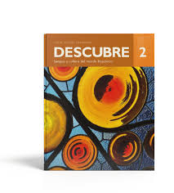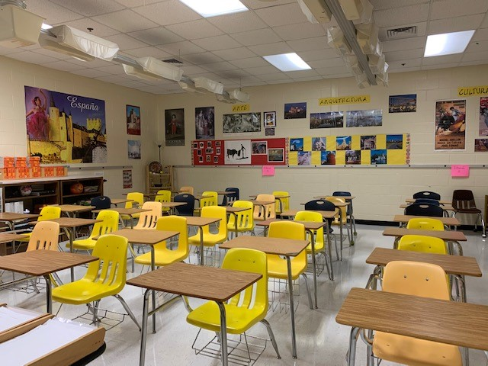

*Students are financially responsible for all books issued by CHS. Textbooks may not be left in classrooms and teachers are not responsible for the whereabouts of your book. The copy which was issued must be turned in at the end of the course. You will not receive credit for turning in another student’s book and may not turn in replacement books. The cost of replacement will be assessed to any student that fails to turn in the book they were issued or turns in a damaged book.

ORGANIZATION METHOD:
Make a digital folder for Spanish to organize your assignments, like classwork, vocabulary activity, grammar notes, reading, culture etc.

COURSE DESCRIPTION: The objective of this course is to integrate the new third year concepts with what was learned in Spanish 1 and 2. Communicative skills are emphasized. Cultural information pertaining to the designated topics will be included. Students will read from various literary sources in the target language as well as watch several films in the target language in regard to our study of cultural comparisons and the Hispanic community.

COMMUNICATIVE OBJECTIVES: Within the context of the target language and culture, the student will be able to:
- Understand more detailed questions.
- Give detailed and extended information.
- Ask others for detailed information.
- Understand extended answers to questions.
- Recount, comprehend, and react to a sequence of events that happened personally or to someone else.
- Summarize and discuss a movie, TV program, book, magazine/newspaper article, etc. experienced in either the target or native language.
- Discuss plans for a future event (picnic, holiday, trip, etc.).
- Discuss plans for a career.
- Suggest alternatives (send back unacceptable food, change a departure time, etc.) rather than accept the option offered.
- Influence or encourage someone to do something (change places on a train, return a purchase, etc).
- Seek explanations of the unexpected.
- Give instructions for completing a task.
- Understand and participate in simple conversations (face to face, telephone, etc.).
- Use extended vocabulary to express and share emotions such as hopes, expectations, worries, and fears
- Comprehend and use extended vocabulary to react to current events and issues.
- Create original narrations.
- Draw conclusions.
- Influence, encourage and defend decisions.
- Discuss issues.
- Comprehend the gist of impromptu conversations and inserts personal opinions and information as appropriate
- Seek supporting details in authentic materials
- Comprehend connected discourse.
- Critique literary works appropriate to the level.
- Develop organized summaries, compositions, and/or reports of more than one paragraph.
- Compose pattern poetry.

* Please reference the Georgia Professional Standards and ACTFL links on my blog for a more detailed explanation of what you should be able to do by the end of the course and which ability level you should reach for speaking, writing, etc.
The goal of the Fulton County Schools World Languages department is to guide students in their mastery of the national performance standards, adopted by the State of Georgia.

For Modern Languages, these standards consist of “The 5 Cs”:
Communication – students will engage in conversations, understand and interpret spoken and written language, and present information on a variety of topics.
Culture – Students will learn about target culture products, practices and perspectives.
Connections – Students will connect aspects of their target language learning with information acquired in other subject areas such as math, science, social studies, English and the arts.
Comparisons – Students will demonstrate an understanding of the nature of language and culture, making comparisons between those of the target language and their own.
Communities – Students will find and engage in the target language outside of the school environment and show evidence of building a life-long skill for their own personal enjoyment and enrichment.

GRADING SCALE:
- 90 and above
- 80-89
- 70-79
F-69 and below OR an incomplete not resolved by end of the school year
I- Incomplete (less than 80% of summative assignments were completed)
NG- No grade

GRADING POLICY:
Final semester grades will be calculated as follows:
1. Major Assessments – 80 % - Quizzes, classwork, and homework weight 1 -compositions, oral assessment, Chapter tests, group /individual projects, weight 2
2. Final exam – 20 %

VIRTUAL CLASS EXPECTATIONS:

Be on time  Wake up early  Long on a few minutes before  class  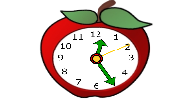  This Photo by Unknown Author is licensed under CC BY-SA | Be in a quiet place  Find a quiet place  Check your surroundings | Be Prepared  Computer is charged  Camera is on  Use headphones if you have them  This Photo by Unknown Author is licensed under CC BY-NC-ND
Presentation  Wear appropriate clothing  Sit up straight  Be in camera view  This Photo by Unknown Author is licensed under CC BY-NC-ND | Mute yourself  Mute yourself when your teacher or another student is talking | Participation  Be focused  Be attentive  Be on active participation  This Photo by Unknown Author is licensed under CC BY-SA-NC
Chat responsibility  Raise your hand to speak  Type your question in the chat box  This Photo by Unknown Author is licensed under CC BY-SA | Communication  Speak clearly  Look up when speaking  Stay on topic  (no side conversation)  This Photo by Unknown Author is licensed under CC BY | Be respectful  R-E-S-P-E-C-T  Be kind  Be considerate  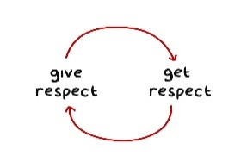  This Photo by Unknown Author is licensed under CC BY-NC-ND

MAKE-UP POLICY:
- Consistent daily attendance is essential to this language course; therefore, absences should be avoided when possible. We will be watching many video clips and doing aural lab work that you will need to keep up with, so it is recommended that you maintain a good attendance to stay abreast of our class work.
- Missed graded work must be made up within 5 school days after the absence occurs unless other arrangements are made with me. Any work not made up within this time will receive a “0”. If you have tag or are on a field trip, you are NOT absent and MUST submit your work for that day. You are responsible for the following day’s assignments.
- Make-ups must be arranged on the day of your return. Please sign up on the classroom calendar on the designated days.
- If you are present on the day that an assignment is announced (ie: test /quiz), you are expected to take it in class on the day that it is given.
- IT IS THE STUDENT’S RESPONSIBILITY TO FIND OUT WHAT HAS BEEN MISSED AND TO HAVE IT TURNED IN ON TIME WITHOUT A REMINDER FROM THE INSTRUCTOR. Please see the classroom make-up folder for handouts/daily plans that you have missed.
- Extra Help is available when needed. During the office hours by appointment
- Recommended Buddy System: I suggest that you get the contact information from a classmate if you are absent and need to follow up on what work was missed.
- Group Work: If you know that you will be absent on the day that your group project will be presented; you are expected to contact me and your group members before class to avoid confusion and late grades.

RECOVERY POLICY:
Chattahoochee High School Provision for Improving Grades

1. Students who complete a major assessment but fail to demonstrate mastery as evidenced by a grade below 75% on the major assessment may pursue an improvement opportunity to show proficiency. In the case of an honor code violation on a major assessment, the grade will stand as a zero with no eligibility for recovery on that assignment. What is classified as a major assessment is determined within the content area; consult your course syllabus for details.
2. Students should contact the teacher concerning recovery opportunities within 5 school days of being informed of the grade on the assessment in class. Students are allowed one attempt at recovery per major assessment category listed in the course syllabus. All recovery work must be completed 10 days before the end of the semester.
3. The grade on the recovery assignment will replace the original grade if the recovery grade is equal to or below 75%. If the recovery grade is above 75%, the original grade will be replaced with a 75%.
School Board Policy IHA Grading and Reporting System

Provision for Improving Grades
1. Opportunities designed to allow students to recover from a low or failing cumulative grade will be allowed when all work required to date has been completed and the student has demonstrated a legitimate effort to meet all course requirements including attendance. Students should contact the teacher concerning recovery opportunities. Teachers are expected to establish a reasonable time period for recovery work to be completed during the semester. All recovery work must be directly related to course objectives and must be completed ten school days prior to the end of the semester.
2. Teachers will determine when and how students with extenuating circumstances may improve their grades.
Chattahoochee Honor Code Policy
In an effort to encourage fair assessments and to authenticate learning, the Chattahoochee faculty supports a strong policy against cheating. Unless directly stipulated by the teacher, collaboration on class work, assignments, and homework is not acceptable. Students who willingly provide other students with access to their work are in violation of the CHS Honor Code. Students guilty of cheating will receive a grade of "0" on the assignment or test. The assignment may not be made up (students who have a “0” are not eligible for recovery).
Additionally, an Honor Code Violation Form will be completed by the teacher and filed with the administration. Violations may be considered by faculty in making future recommendations for membership in honor clubs. Students receiving an Honor Code violation will be assigned to serve two (2) days of Saturday School for the first offense.

Plagiarism Statement
Acts of plagiarism include, but are not limited to:
- use of words or ideas from a published source without proper documentation.
- Use of Google translator or any other online translation
- use of the work of another student (e.g. copying another student’s homework, composition, or project)
- use of excessive editing suggestions of another student, teacher, parent or paid editor.

Students are expected to attend virtual class meetings according to their course schedule. If unable to attend a class meeting, students should contact the teacher on Microsoft TEAMS in order to access content they missed.

Resources:
Class information is posted on TEAMS, our class page
For assignments and daily work, we use Microsoft TEAMS and www.vhlcentral.com www.conjuguemos.com/spanish www.kahoot.com www.quizziz.com www.studyspanish.com www.colby.edu/~bknelson/exercises
www.quizlet.com
www.edpuzzle.com
Use the code to sign up and practice

Let’s have a great year ahead with much success and Spanish language enrichment!

