CHATTAHOOCHEE HIGH SCHOOL
SPANISH 3 - Sra. Nadia Ali
COURSE SYLLABUS 2020-2021
Virtual Office Hour: 7:40-8:40 by appointment

Materials:
- Descubre 2 ISBN: 9781680046694 Vista Higher learning textbook $95.00
- Digital textbook through VHL central during URL www.vhlcentral.com
- Spanish- English dictionary @ https://www.wordreference.com/

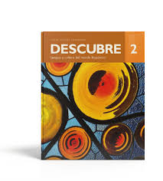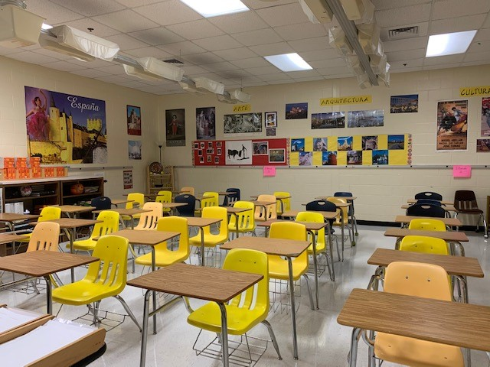
Course Description:

This course integrates a systemic review of first- and second-year concepts with the new third year materials. While the course does base itself in the learning of new grammar, cultural and conversational elements will be introduced as well. This course requires outside preparation for each class. Learning a foreign language requires consistency and persistency.

The goal of the Fulton County Schools World Languages department is to guide students in their mastery of the national performance standards, adopted by the State of Georgia. Please see the teacher’s site for a link to the full Georgia Performance Standards.

For Modern Languages, these standards consist of “The 5 Cs”:
Communication – students will engage in conversations, understand and interpret spoken and written language, and present information on a variety of topics.
Culture – Students will learn about target culture products, practices and perspectives.
Connections – Students will connect aspects of their target language learning with information acquired in other subject areas such as math, science, social studies, English and the arts.
Comparisons – Students will demonstrate an understanding of the nature of language and culture, making comparisons between those of the target language and their own.
Communities – Students will find and engage in the target language outside of the school environment and show evidence of building a life-long skill for their own personal enjoyment and enrichment.

WL Resources, guides and forms webpage:
https://employees.fultonschools.org/academics/landt/humanities/WorldLanguages/Pages/Default.aspx

- Semester one: Review of Spanish 2 material. In depth study of the past tenses.
Lección Preliminar, Lección 1 and Lección 2.
- Semester two: Lesson 3 through Lesson 5.
Review of past tenses. Study of the subjunctive mood.

To get a jump start on the units we will study this year, I suggest:
- Taking a field trip with your family to use Spanish at the Hispanic grocery stores, bakeries, and restaurants. Watching Spanish TV channels, listening to music and reading the newspaper in Spanish.
- Learning, practicing vocabulary and grammar, and reviewing for quizzes and tests at the following web sites:
www.vhlcenttral.com www.conjuguemos.com/spanish www.kahoot.com www.quizziz.com www.studyspanish.com www.colby.edu/~bknelson/exercises
www.edpuzzle.com www.quizlet.com

Students are expected to attend virtual class meetings according to their course schedule. If unable to attend a class meeting, students should contact the teacher on Microsoft TEAMS in order to access content they missed.

Online component:
Information pertaining to this course such as tests, quizzes, projects, due dates, course resources, and other electronic communication will be available on Microsoft TEAMS and related links.
Organization Method:
Make a digital folder for Spanish to organize your assignments, like classwork, vocabulary activity, grammar notes, reading, culture etc.

Assessment and Evaluation:
There will be frequent and varied assessments throughout the semester. Throughout the course will be both oral and written tests, and oral and written quizzes, oral participation, homework, projects, presentations, and compositions. The percentages breakdown into the following:

- Major Assessments – 80 % - Quizzes, class work and homework weight 1
compositions, oral assessment, Chapter tests, group /individual projects weight 2
- Final exam – 20 %
GRADING SCALE:
- 90 and above
- 80-89
- 70-79
F-69 and below OR an incomplete not resolved by end of the school year
I- Incomplete (less than 80% of summative assignments were completed)
NG- No grade

Make up Policy:
Missed work will be made up according to the Fulton County/CHS policy. Missed work or evaluations are expected to be made up as soon as possible. If you have TAG or a field trip, you are not absent and MUST submit work and be responsible for assignments for the following day. IT IS THE STUDENT’S RESPONSIBILITY TO TURN IN ASSIGNMENTS AND TO MAKE ARRANGEMENTS TO MAKE UP THE WORK BEFORE OR AFTER SCHOOL. MAKE UP SESSIONS WILL BE DURING OFFICE HOURS.
Students and parents need to remember that absence from class on any given day removes a student from active classroom participation and group dynamics. These activities cannot be replaced by one-on-one make up sessions. Therefore, it is imperative that students be in attendance for all classes barring serious illness. When you are absent, please check the TEAMS with questions, assignment requests ,etc.

VIRTUAL CLASS EXPECTATIONS:
Be on time  Wake up early  Long on a few minutes before  class  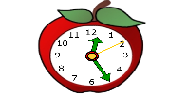  This Photo by Unknown Author is licensed under CC BY-SA | Be in a quiet place  Find a quiet place  Check your surroundings | Be Prepared  Computer is charged  Camera is on  Use headphones if you have them  This Photo by Unknown Author is licensed under CC BY-NC-ND
Presentation  Wear appropriate clothing  Sit up straight  Be in camera view  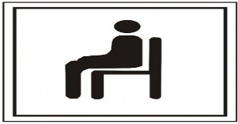  This Photo by Unknown Author is licensed under CC BY-NC-ND | Mute yourself  Mute yourself when your teacher or another student is talking | Participation  Be focused  Be attentive  Be on active participation  This Photo by Unknown Author is licensed under CC BY-SA-NC
Chat responsibility  Raise your hand to speak  Type your question in the chat box  This Photo by Unknown Author is licensed under CC BY-SA | Communication  Speak clearly  Look up when speaking  Stay on topic  (no side conversation)  This Photo by Unknown Author is licensed under CC BY | Be respectful  R-E-S-P-E-C-T  Be kind  Be considerate  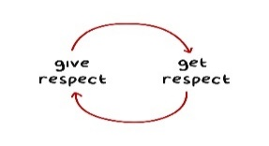  This Photo by Unknown Author is licensed under CC BY-NC-ND

Chattahoochee High School Provision for Improving Grades
1. Students who complete a major assessment but fail to demonstrate mastery as evidenced by a grade below 75% on the major assessment may pursue an improvement opportunity to show proficiency. In the case of an honor code violation on a major assessment, the grade will stand as a zero with no eligibility for recovery on that assignment. What is classified as a major assessment is determined within the content area; consult your course syllabus for details.
2. Students should contact the teacher concerning recovery opportunities within 5 school days of being informed of the grade on the assessment in class. Students are allowed one attempt at recovery per major assessment category listed in the course syllabus. All recovery work must be completed 10 days before the end of the semester.
3. The grade on the recovery assignment will replace the original grade if the recovery grade is equal to or below 75%. If the recovery grade is above 75%, the original grade will be replaced with a 75%.

School Board Policy IHA Grading and Reporting System
Provision for Improving Grades

1. Opportunities designed to allow students to recover from a low or failing cumulative grade will be allowed when all work required to date has been completed and the student has demonstrated a legitimate effort to meet all course requirements including attendance. Students should contact the teacher concerning recovery opportunities. Teachers are expected to establish a reasonable time for recovery work to be completed during the semester. All recovery work must be directly related to course objectives and must be completed ten school days prior to the end of the semester.
2. Teachers will determine when and how students with extenuating circumstances may improve their grades.

Help session: will be provided during office hours
Chattahoochee Honor Code Policy:
To encourage fair assessments and to authenticate learning, the Chattahoochee faculty supports a strong policy against cheating. Unless directly stipulated by the teacher, collaboration on class work, assignments, and homework is not acceptable. Students who willingly provide other students with access to their work are in violation of the CHS Honor Code. Students will receive a “0” on the assignment or test. An Honor Code Violation Form will be completed by the teacher and filed with the administration. Violations may be considered by faculty in making future recommendations for membership in honors clubs, and students will not be eligible for recovery.

Chattahoochee Plagiarism Statement:
Acts of plagiarism include, but are not limited to:
- Use of words or ideas from a published source without proper documentation.
- Use of the work of another student (e.g. copying another student’s homework, composition, or project).
- Use of excessive editing suggestions of another student, teacher, parent or paid editor.
- Use of an on-line or electronic translator.

I AM LOOKING FORWARD TO A GREAT YEAR!!!

